The Ottawa Hospital Annual Report
2019-2020

Messages from leaders

The Ottawa Hospital
The Board of Governors would sincerely like to thank Dr. Jack Kitts for his 18 years of exceptional service as the hospital’s President and CEO. Under Jack’s inspiring leadership, the Ottawa Hospital has built an international reputation of excellence in care, education and research. His unwavering commitment to his vision has helped transform health care in Ottawa, the region and across Canada, and he leaves a lasting legacy of providing compassionate, patient-centered care.
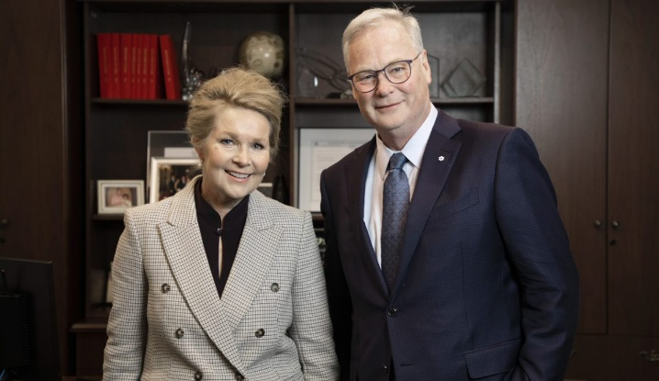
This year, the words ‘thank you’ just don’t seem big enough to express our deep appreciation to the community for their support during the COVID-19 pandemic. The letters, signs, and videos inspired so many of us, working inside and outside the hospital, to continue providing world-class, compassionate care to our patients in some of the most challenging circumstances we have ever faced.
Katherine Cotton, Chair, Board of Directors, The Ottawa Hospital, and Dr. Jack Kitts, President and CEO, The Ottawa Hospital
Thank you seems equally too small a phrase to express the gratitude we have for all the health-care providers, staff, researchers, allied health professionals, public health authorities and levels of government who came together in extraordinary ways to respond to the needs of the community. Over our time at The Ottawa Hospital, but especially in the past 12 months, we have been so fortunate to witness the finest examples of kindness, courage and discovery.
There is no doubt that this pandemic has forever changed how health care is delivered. In many ways, the experience has affirmed that the hospital is ready to embrace the future and continue to be a leader in innovation.
Over the past year, The Ottawa Hospital has made great strides in pushing innovation forward. We set up the region’s first COVID-19 Assessment Centre in just three-and-a-half days to divert non-urgent cases away from our Emergency Department. We developed strategic partnerships with international organizations like Sheba Medical Centre in Israel to form an ARC, a public policy tool designed to accelerate redesign through collaboration. We also successfully launched Epic, our digital health information system. Together, we will continue to foster innovation in pursuit of better patient experience, better staff experience, better value, and healthier populations.
Our new 21st-century hospital will set the standard for patient-centred, environmentally sensitive design. Through community and staff engagement, and steady progress with all three levels of government, we continue to make steady progress toward building the hospital of the future where innovation is woven deep within the culture.
Innovation will continue to be a focus as we welcome Cameron Love as the new President and CEO. Cameron is exceptionally talented and embodies the tenacity and warmth needed to lead this hospital into its bright future. We can say with confidence that we are all in great hands.
Katherine Cotton
Chair, Board of Governors, The Ottawa Hospital
DR. Jack Kitts
President and CEO of The Ottawa Hospital

Ottawa Hospital Research Institute
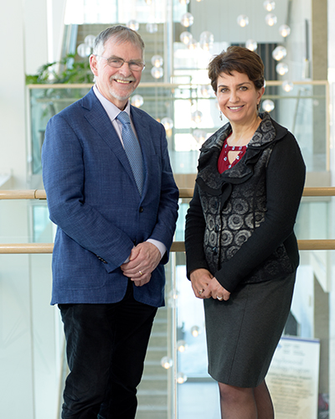
In this unprecedented time of global pandemic, the importance of health research has never been more obvious.
Scientists from around the world are working collaboratively to develop new ways to prevent and treat COVID-19, and researchers at The Ottawa Hospital are stepping up to take a leadership role in this global fight.
More than 50 individual COVID-19 projects have been initiated, ranging from the development of vaccines to novel therapies. We are immensely proud of how our scientists and everyone at our Research Institute has risen to this enormous challenge.
Dr. Duncan Stewart, CEO and Scientific Director, The Ottawa Hospital Research Institute, Executive Vice-President, Research, The Ottawa Hospital, Professor, University of Ottawa
Patricia Kosseim, Chair, Board of Directors, The Ottawa Hospital Research Institute
That we are on the cutting edge of COVID-19 research should not come as a big surprise, given that our research has been having a global impact well before this crisis. Examples from this year include:

- Dr. Barbara Vanderhyden’s team discovered that a medication commonly used to treat Type 2 diabetes, might hold promise for helping to prevent ovarian cancer.
- Dr. Michael Schlossmacher’s team revealed how one gene called LRRK2 is the common link to three different diseases: Parkinson’s, Crohn’s, and leprosy. This knowledge could lead to new treatments and preventions for all three conditions.
- Dr. Daniel McIsaac and his team launched a cross-Canada clinical trial of exercise before surgery known as “pre-hab”. Trial participant Marie Lapointe, 66, credits the study with helping her get back to golfing several times a week after her lung cancer surgery.
- Dr. Marjorie Brand and her team discovered how blood stem cells decide what to be when they “grow up” – a breakthrough that could lead to new therapies for many diseases.
"We’re proud to be one of Canada’s most successful research hospitals, publishing almost 2,000 scientific papers in 2019, many of which have helped to transform health care around the world. The Ottawa Hospital is also one of the top hospitals in Canada for attracting external research funding, ranking fourth out of more than 600 hospitals for funding from the Canadian Institutes of Health Research, and fifth for overall research funding.
But we also know that today’s successes will be followed by new and perplexing health care challenges tomorrow. And that is why our new Corporate Strategic Plan provides a roadmap for how we will meet those challenges so that patients at The Ottawa Hospital, and indeed, around the world, can benefit.
We thank all our researchers, staff, trainees, volunteers and patient partners for their dedication and hard work, especially as we face the challenge of COVID-19. We also thank our partners at the University of Ottawa and The Ottawa Hospital Foundation as well as our many generous donors.
Our sincere wish is for everyone to stay safe and healthy during this difficult time.
Patricia Kosseim
Chair, Board of Directors, Ottawa Hospital Research Institute
Dr. Duncan Stewart
CEO and Scientific Director, Ottawa Hospital Research Institute
Executive Vice-President, Research, The Ottawa Hospital
Professor, University of Ottawa
The Ottawa Hospital Foundation

Strange days, indeed. John Lennon wrote those lyrics more than 40 years ago, but they have a particular resonance today.
For the last several months, we have all been focused on adapting to and navigating this strange new reality dictated by COVID-19. And as we reflect on the 2019-20 fiscal year at the Foundation, we have much to celebrate. Fundraising milestones were met and exceeded; lifesaving equipment and groundbreaking research were funded.
Tim Kluke, President and CEO, The Ottawa Hospital Foundation and Michael Runia, Chair, Board of Directors
In March, when we were suddenly faced with COVID-19, we quickly created the COVID-19 Emergency Response Fund to help purchase much-needed equipment and PPE, and to support important innovation, care, and research projects. We were humbled by the generous outpouring of support from the Ottawa community and donors across the country. The hospital’s response to our community’s needs during this pandemic has also been crucial. We have been able to work with the hospital to put your donations to work right away, ensuring the immediate impact of your support.
We are proud to say that we have a long-standing track record for being one of the most efficient and effective hospital foundations in the country. In the face of the pandemic and an uncertain future for philanthropy, we were committed to maintaining this level of excellence and to being good stewards of the generosity entrusted to us as the hospital’s Foundation, even during challenging times.
The last few months have reminded all of us how vital The Ottawa Hospital is for our city and surrounding area. That is why the Foundation is focused not only on the needs of today but also on the needs of tomorrow.
With the help of a caring community, we look ahead to the largest, most important health-care project in the history of our region as we build a new health and research centre to replace the aging Civic Campus. This new hospital campus will be so modern and technologically advanced that it will revolutionize health care in our region and will transform how we care for our patients. This is the healthy future we set our sights on
It is a privilege to be joining together with our generous supporters in creating a healthier tomorrow
Tim Kluke
President and CEO, The Ottawa Hospital Foundation
Michael Runia
Chair, Board of Directors, The Ottawa Hospital Foundation

Fast facts
- 4435 Nurses
- 12,411 Employees
- 1,447 Physicians
- 155 Fellows
- 983 Resident physicians
- 31 Midwives
- 593 Technicians and technologists
- 1034 Allied health
- 201 Patient advisors
- 1,400 Volunteers
- 2,273 Researchers
Learners group
- 655 Medical students
- 1,484 Nursing students
- 550 Students in other health professions
- 50 Students in non-health professions
- 80 paramedic student placements
The numbers represented above may not account for some overlap in duties.
- Fourth in Canada for peer-reviewed funding from the Canadian Institutes of Health Research
- Fifth in Canada for overall research funding
- $1.8B Impact on Ottawa economy due to our research (since 2001)
- 1953 Scientific papers published in 2018
- 52 Active patent families
- 9 Spin-off companies
- 1,224 Beds
- 18 State-of-the-art core research facilities
- 62 Scientific research labs
- 7 National research networks
- 734 Active clinical trials
- 12,371 Patients enrolled in clinical trials
- 7.7 Average length of stay (days)
- 60,247 Patient admissions
- 175,200 Emergency visits
- 1,125,580 Ambulatory care visits
- 50,335 Surgical cases
- 6,341 Babies delivered

Corporate performance scorecard
At The Ottawa Hospital, excellence in patient care is our priority. By improving wait times, patients’ rating of experience and other key measures of a high-performing hospital, our goal is to rank among the top 10 percent of North American hospitals in providing safe, high-quality care to our patients.
- Strategic Direction: Finance
Indicator:
- Cost per weighted case – acute and day surgery patients: average cost of standard hospital stay for an acute or day-surgery patient
2019-2020 Result: $6,328*
- Total Margin: Percent by which consolidated revenues vary from consolidated expenses. Negative variance indicates revenues are lower than expenses; positive variance indicates revenues are higher than expenses.
2019-2020 Result: -.43%
- Progress on Keystone Projects: A composite project milestone score with 80% of the score weighted towards the new Health Information System implementation, and 20% towards planning for the new campus of The Ottawa Hospital. Each project is rated on a 3-point scale where 1 means major concerns on budget or milestones and 3 means project is on budget and on time.
  - Result: 2.8
- Strategic Direction: Quality
Indicator:
- Percent of admitted patients who rated their experience as 9 or 10 out of 10.
2019-2020 Result: 69%*
- Hospital standardized mortality ratio (HSMR): Ratio of actual deaths to the number of expected deaths. A ratio greater than 100 means more deaths occurred than expected; a ratio less than 100 means fewer deaths occurred than expected.
2019-2020 Result: 85
- Percentage of patients admitted through the Emergency Department who waited 24 hours or less before admission.
2019-2020 Result: 72%
- Strategic Direction: People
Indicator:
- Absenteeism – annualized (sick days per full-time employee):
2019-2020 Result: 13.9*
- Staff Incidents – reportable (avg. per 30 days):
2019-2020 Result: 53.1
- Strategic Direction: Partners
Indicator:
- 30-day unplanned readmissions: Percent of patients readmitted within 30 days of hospital discharge.
2019-2020 Result: 9.4%*
- ALC rate:
Percent of inpatient beds that are occupied by patients in an alternate level of care (ALC). These patients no longer require acute care and are waiting for discharge supports like homecare or for placement in a downstream facility.
2019-2020 Result: 17.0%
- Academics: Based on a 5-point score. Calculated from:
- The number of research studies published
- The number of times published research is cited
- The number of patients participating in clinical trials
- The number of patients consenting to be contacted for research purposes
- The amount of external funding received
2019-2020 Result: 4.3*
*Measurable improvement during fiscal year

Financials
The Ottawa Hospital

Revenue distribution 2019-2020
- Ontario Ministry of Health and Long-Term Care – 74%
- Sundry and ancillary – 12%
- Patient services – 11%
- Amortization of grants – 2%
- Preferred accommodation and copayment – 1%

Total: $1,482M
Expenditure distribution 2019-2020
- Salaries – 57%
- Other supplies – 19%
- Medical and surgical supplies – 8%
- Drugs and gases – 6%
- Medical staff – 5%
- Depreciation and amortization – 5%
Total: $1,420M

Ottawa Hospital Research Institute

Revenue distribution 2019-2020
- External grants, contracts, and salary awards – 76%
- The Ottawa Hospital Foundation – 9%
- The Ottawa Hospital – 8%
- Indirect cost and investment income – 6%
- University of Ottawa – 1%

Total: $118.9M

Expenditure distribution 2019-2020
- Research project expenses – 72%
- Scientific salaries – 16%
- Other research expenses – 5%
- Administrative expenses – 4%
- Amortization of capital assets – 3%

Total: $118.9M

Top 10 sources of peer-reviewed funding
- Canadian Institutes of Health Research - $20.35M
- Networks of Centres of Excellence - $3.15M
- Ontario Ministry of Health and Long-Term Care - $1.48M
- Heart and Stroke Foundation of Canada - $1.12M
- Canada Foundation for Innovation - $1.06M
- The Ottawa Hospital Academic Medical Organization - $1.04M
- Ontario Institute for Regenerative Medicine - $0.95M
- Strategy for Patient-Oriented Research (SPOR) SUPPORT Units - $0.86M
- Ontario Institute for Cancer Research (OICR) - $.85M
- Bill and Melinda Gates Foundation - $.59M

