The Ottawa Hospital Annual Report
2018-2019

Messages from leaders

The Ottawa Hospital
On June 1, The Ottawa Hospital and five other health organizations in Eastern Ontario ushered in a new era of care. The Epic digital health network securely organizes and stores patient health records across the six health-care partners. Tell your story once, and wherever you go in the network, members of your health team are connected and ready to help.
Patients who sign up for the new MyChart patient portal will have secure access to their digital health records all in one place. Through MyChart, patients can access their health records, test results, and much more from their computer or mobile device. Learn more at The Ottawa Hospital website.
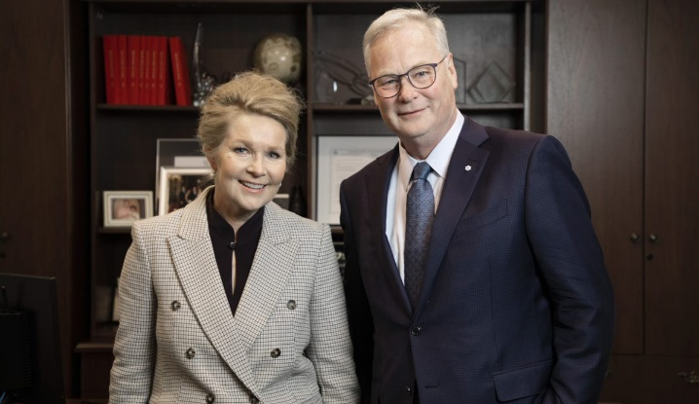

Katherine Cotton, Chair, Board of Directors, The Ottawa Hospital, and Dr. Jack Kitts, President and CEO, The Ottawa Hospital

Last year, we were all reminded of how tragedy can hit close to home. When the people of Ottawa were faced with tornadoes in September 2018 and then a bus crash in January 2019, our community came together in many ways to help each other.
As the Regional Trauma Centre for Eastern Ontario, The Ottawa Hospital is prepared to respond to large-scale catastrophic events.
We spend a great deal of time training for all kinds of emergencies so that we are ready when our community needs us. When tragedy strikes, patients can take comfort knowing that a world-class team of health-care professionals and support staff will be there for them in their time of need. And in September 2018 and January 2019, we were ready.
The Ottawa Hospital’s doctors, nurses, staff and volunteers rallied together to care for the injured and comfort their families.
Being ready also means being ready for the future – a future that as of June 1st included a new health information system called Epic and a digital patient portal called MyChart. Both of these technologies bring our health care into a secure digital age, while keeping compassionate patient care at the centre of everything we do.
Epic and MyChart are just two of the many inspiring examples of innovation and care from the past year. Others include how 3-D virtual reality could help treat patients with Parkinson’s disease and how staff took part in a special exercise to better understand the needs of First Nation, Métis and Inuit patients and families.
Our vision is to provide each patient with the world-class care, exceptional service and compassion we would want for our loved ones through our values of compassion, a commitment to quality, working together and respect for the individual. The stories in this report reflect our deep and ongoing commitment to these principles.
As we enter a digital age, we must always remember that our human connection defines our care. At The Ottawa Hospital, we are proud of the inspiration, compassion and readiness of our people who connect us to this extraordinary community – one patient at a time.
Katherine Cotton
Chair, Board of Governors, The Ottawa Hospital
DR. Jack Kitts
President and CEO of The Ottawa Hospital

Ottawa Hospital Research Institute
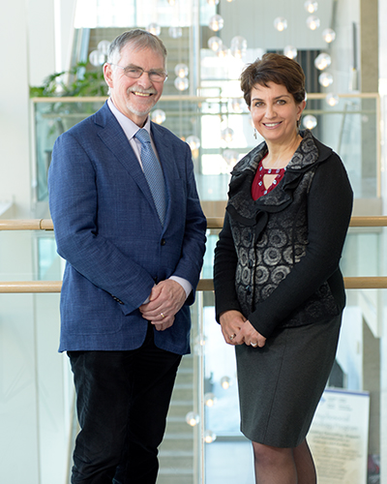

Dr. Duncan Stewart, CEO and Scientific Director, The Ottawa Hospital Research Institute, Executive Vice-President, Research, The Ottawa Hospital, Professor, University of Ottawa and Patricia Kosseim, Chair, Board of Directors, The Ottawa Hospital Research Institute.

Patients and families have come to expect world-class, compassionate care at The Ottawa Hospital and research is one of the key ingredients that makes this possible. Research allows us to offer innovative new therapies and continuously improve our techniques and practices. It also provides hope at times when people may have little else.
All of our researchers are driven not only by the desire to advance science, but also by the real, positive impact their research can have on improving the health and lives of patients. For example, Dr. Rebecca Auer, our new head of cancer research, has seen how research gives her patients hope. When she isn’t meeting with patients or removing their tumours in the operating room, she’s working in the lab and leading clinical trials of innovative new treatments. Her colleague, Dr. William Stanford, a basic researcher in stem cell biology, also understands the need for hope and patients have inspired him to develop promising strategies to treat blood cancer and rare lung diseases.
The Ottawa Hospital is a leader in moving research into everyday practice. For example, a clinical trial led by Dr. Marc Carrier and Dr. Philip Wells is already changing how cancer is treated around the world and sparing thousands of patients from dangerous blood clots. Similarly, Dr. Venkatesh Thiruganasambandamoorthy’s team has developed new guidelines that can identify which patients who faint need to receive specialized care for potential heart problems.
In addition to changing lives here in Ottawa, our research has global reach. The number of highly influential research papers we publish has grown by 50 percent over the last three years. The Ottawa Hospital is also one of the top hospitals in Canada for attracting external research funding, ranking third out of more than 600 hospitals for funding from the Canadian Institutes of Health Research, and fifth for overall research funding.
We thank all our researchers, staff, trainees and volunteers for their dedication and hard work, which is redesigning the future of health care. We also thank our partners at the University of Ottawa as well as our many generous donors, through The Ottawa Hospital Foundation.
But our biggest thanks of all goes to the individual patients who put their trust in us by agreeing to participate in our studies and helping us solve some of the most vexing health issues of our time for the benefit of their families, other patients like them and future generations to follow.
Patricia Kosseim
Chair, Board of Directors, Ottawa Hospital Research Institute
Dr. Duncan Stewart
CEO and Scientific Director, Ottawa Hospital Research Institute
Executive Vice-President, Research, The Ottawa Hospital
Professor, University of Ottawa

The Ottawa Hospital Foundation
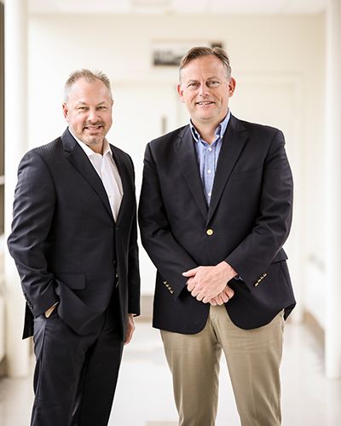

Tim Kluke, President and CEO, The Ottawa Hospital Foundation and Jim Harmon, Chair, Board of Directors

In September 2018, the doors opened at the Rose Ages Breast Health Centre, marking the wonderful close of an ambitious $14 million fundraising campaign that highlighted our community’s outstanding generosity. A month later, six 11-year-old children arrived at the new centre with a sandwich bag of money, all $247.95 of it, to donate to breast cancer research and the legacy of a healthy tomorrow for a hospital they will in all likelihood use in the future.
Philanthropy does change lives today and for tomorrow, in Ottawa and around the world. It is generous community support that enables us to open new centres of health-care excellence. It leads to exciting advances in technology, such as using 3D printers and virtual reality to help surgeons. It boosts research that makes new healing treatments possible, such as with immunotherapy and stem cells. And it enables us to conduct innovative, first-in-human clinical trials to improve treatment for devastating diseases.
The bottom line is our talented scientists and physicians can't do cutting-edge research or revolutionize health care without donors who help provide the necessary tools — such as the labs and state-of the-art equipment. Community support plays a huge role in achieving the astounding results and changing patient outcomes you will read about in this annual report.
Without a doubt, this is a health research centre for the next generation. We all have our eye on the horizon that includes a beautiful, new, state-of-the-art campus, which will impact our entire region. This will be one of the most exciting projects in our city’s history, and we are thrilled to embark on this project with our community’s support. This new campus will not only redesign the face of our city, but the face of our health-care future.
We wouldn’t be where we are in reimagining health care if it weren’t for the incredible generosity of our community. Philanthropy is making a remarkable difference in the health of our community right now and for future generations.
Gratefully,
Tim Kluke
President and CEO, The Ottawa Hospital Foundation
Jim Harmon
Chair, Board of Directors, The Ottawa Hospital Foundation

Fast facts
- 4443 Nurses
- 12,297 Employees
- 1,511 Physicians and Midwives
- 1205 Residents and Fellows
- 51 paramedic student placements
- 652 Medical students
- 1,867 Nursing placements
- 1,200 Volunteers
2,257 Total researchers:
- 136 Basic and clinical Scientists
- 684 Clinical investigators
- 464 Trainee researchers
- 973 Research support staff

- Third hospital in Canada for peer-reviewed funding from the Canadian Institutes of Health Research
- Fifth in Canada for overall research funding
- $1.6B Impact on Ottawa economy due to our research (since 2001)
- 1,740 Scientific papers published in 2017
- 57 Active patent families
- 9 Spin-off companies
- 1,232 Beds
- 18 State-of-the-art core research facilities
- 62 Scientific research labs
- 8 National research networks
- 825 Active clinical trials
- 14 Made-in-Ottawa Clinical decision rules
- 7.9 Average length of stay (days
- 60,457 Patient admissions
- 179,651 Emergency visits
- 1,196,050 Ambulatory care visits
- 51,799 Surgical cases
- 6,166 Babies delivered

Corporate performance scorecard
At The Ottawa Hospital, excellence in patient care is our priority. By improving wait times, patients’ rating of experience and other key measures of a high-performing hospital, our goal is to rank among the top 10 percent of North American hospitals in providing safe, high-quality care to our patients.
- Strategic Direction: Finance
Indicator:
- Cost per weighted case – acute and day surgery patients: average cost of standard hospital stay for an acute or day-surgery patient
2018-2019 Result: $6,388
- Total Margin: Percent by which consolidated revenues vary from consolidated expenses. Negative variance indicates revenues are lower than expenses; positive variance indicates revenues are higher than expenses.
2018-2019 Result: 0.06%*
- Progress on Keystone Projects: A composite project milestone score with 80% of the score weighted towards the new Health Information System implementation, and 20% towards planning for the new campus of The Ottawa Hospital. Each project is rated on a 3-point scale where 1 means major concerns on budget or milestones and 3 means project is on budget and on time.
2018-2019 Result: 3*
- Strategic Direction: Quality
Indicator:
- Percent of admitted patients who rated their experience as 9 or 10 out of 10.
2018-2019 Result: 69%
- Hospital standardized mortality ratio (HSMR): Ratio of actual deaths to the number of expected deaths. A ratio greater than 100 means more deaths occurred than expected; a ratio less than 100 means fewer deaths occurred than expected.
2018-2019 Result: 84

- Percentage of patients admitted through the Emergency Department who waited 24 hours or less before admission.
2018-2019 Result: 80%*
- Strategic Direction: People
Indicator:
- Absenteeism – annualized (sick days per full-time employee):
2018-2019 Result: 14.1*
- Staff Incidents – reportable (avg. per 30 days):
2018-2019 Result: 48.3
- Strategic Direction: Partners
Indicator:
- 30-day unplanned readmissions: Percent of patients readmitted within 30 days of hospital discharge.
2018-2019 Result: 9.9%
- ALC rate:
Percent of inpatient beds that are occupied by patients in an alternate level of care (ALC). These patients no longer require acute care and are waiting for discharge supports like homecare or for placement in a downstream facility.
2018-2019 Result: 15.4%
- Academics: Based on a 5-point score. Calculated from:
- The number of research studies published
- The number of times published research is cited
- The number of patients participating in clinical trials
- The number of patients consenting to be contacted for research purposes
- The amount of external funding received
2018-2019 Result: 3.8*
*Measurable improvement during fiscal year

Financials
The Ottawa Hospital

Revenue distribution 2018-2019
- Ontario Ministry of Health and Long-Term Care – 77%
- Patient Revenues – 12%
- Sundry and ancillary – 8%
- Amortization of grants – 2%
- Preferred accommodation and copayment – 1%
- Connecting Northern and Eastern Ontario – 0%

Total: $1,385M
Expenditure distribution 2018-2019
- Salaries – 58%
- Other supplies – 18%
- Medical and surgical supplies – 8%
- Drugs and gases – 6%
- Medical staff – 5%
- Depreciation and amortization – 5%
- Connecting Northern and Eastern Ontario – 0%
Total: $1.388M

Ottawa Hospital Research Institute

Revenue distribution 2018-2019
- External grants, contracts, and salary awards – 73%
- Indirect cost and investment income – 11%
- The Ottawa Hospital Foundation – 9%
- The Ottawa Hospital – 6%
- University of Ottawa – 1%

Total: $124.4M

Expenditure distribution 2018-2019
- Research project expenses – 72%
- Scientific salaries – 17%
- Other research expenses – 4%
- Administrative expenses – 4%
- Amortization of capital assets – 3%

Total: $119.2M

Top 10 sources of peer-reviewed funding
- Canadian Institutes of Health Research - $22.71M
- Ontario Research Fund - $2.32M
- Ontario Institute for Cancer Research (OICR) - $1.84M
- The Ottawa Hospital Academic Medical Organization - $1.55M
- Ontario Ministry of Health and Long-Term Care - $1.53M
- Public Health Agency of Canada - $1.40M
- Canada Foundation for Innovation - $1.21M
- Heart and Stroke Foundation of Canada - $1.19M
- Canada Foundation for Innovation - $1.21M
- Stem Cell Network - $1.12M

